**2020年河北省初中毕业生升学文化课考试**

**英语试卷**

**注意事项：1.本试卷共8页，总分120分，考试时间120分钟。**

**2.答题前，考生务必将姓名、准考证号填写在试卷和答题卡相应位置上。**

**3.答选择题时，每小题选出答案后，用2B铅笔把答题卡上对应题目的答案标号涂黑；答非选择题时，将答案写在答题卡上。写在本试卷上无效。**

**4.考试结束后，将本试卷和答题卡一并交回。**

**听力部分**

**Ⅰ.听句子，选出句子中所包含的信息**

1. A. read B healthy C. lucky

2. A. a bowl of noodles B a pair of shoe C a box of pencils

3. A. write on the card B. run to the park C. play in the yard

4. A. Mary is nice to the girl. B. Mary is a nice girl. C. Mary knows a nice girl.

5. A. Li Hua speaks English well.

B. Li Hua comes from America.

C Li Hua likes English very much

**Ⅱ.听句子，选出该句的最佳答语**

6. A Hurry up, Peter. B. I’lI call him later. C. Just a minute.

7. A. I won't do it again. B. It doesn't matter. C. You can come earlier.

8. A. Rice and beef. B. Tall and strong. C. Fishing and boating

9. A. It's too hot. B. He’s ill. C. I'm fine.

10. A. What shall I do？ B. What does he mean？ C. But what do you say now

**Ⅲ.听对话和问题，选择正确答案**

11.Where are the speakers?

A. 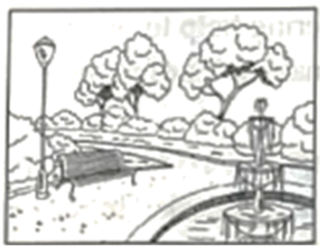 B.  C. 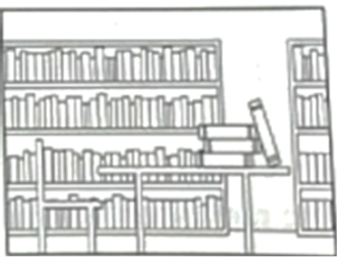

12.What are they doing?

A. 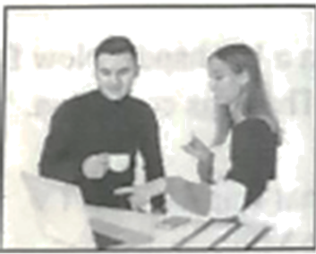 B. 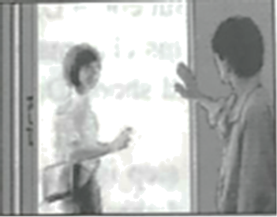 C.

13. How much did the boy pay for his shirt？

A.￡30. B.￡.40 C.￡45

14. What are they going to have？

A. A part. B. A meeting. C. A dinner.

15. How many people will attend it？

A Four. B. Five. C. Six.

16. How long was Cindy's holiday？

A. One week. B. Two week. C. Three week.

17. Where did Cindy and her family stay in Sanya?

A. In a hotel. B. At a friend. C. In their own house.

18. What did they do most of the time？

A. They went camping. B. They took photos. C. They went swimming.

**Ⅳ.听短文和问题，选择正确答案**

19. Who is probably talking？

A. A teacher. B.A guide. C. A parent.

20. What is the speaker trying to do？

A. Tell a story B Give the homework. C. Find something interesting.

21. What do the children have to do tomorrow morning?

A Go to the museum. B Bring a pen with them. C Read their passage

22. Who can take part in the competition？

A. College students. B Middle school students. C Primary school students.

23. When is the competition？

A. On June 15th. B. One June 16th. C. On June 17th

24. What color should the dancers choose for their clothes？

A Red B. Blue C. White

25. What do the dancers need to do to attend the competition？

A. Complete a form B Post a picture C:Send an email

**Ⅴ.听短文文填空**

|  |
| --- |
| Information Sheet  Name: Jim Green  Age: 26.  Place of birth: 27.  Experience: 28.shell in a store  Want to do: 29.work in a shop  Possible working time: 30. Form to September |

**笔试部分**

**Ⅵ.单项选择**

**选出可以填入空白处的最佳选项**

1.When are you arriving? I’ll pick you up the station.

A. at B. to C. on D. off

2.Nancy, carrots are good for eyes. Eat some, please.

A. my B. your C. her D. his dark

3.It dark. Shall I turn on the light？

A. gets B. got C. is getting D. was getting

4. you smell something burning? Go and see what's happening.

A. Can B. May C. Must D. Need

5.In a restaurant, people usually choose food and drink from the .

A. book B. menu C. newspaper D. magazine

6.Helen is the person in her family. Her two elder sisters are both married.

A. older B. oldest C. younger D. youngest

7.Train tickets online. It is convenient.

A. sold B. were sold C. are sold D. have sold

8.Some volunteers are going to the central park. Let's join them.

A. put up B. clean up C. look up D. give up

9.I’m so glad that I nearly half of the test now.

A. finish B. finished C. will finish D. have finished

10.My cousin will drive me to school today, but I don't know .

A. what he'll do B. where he'll go

C. when we'll leave D. why we'll go there

**Ⅶ.完形填空**

**阅读下面短文，从各小题所给的四个选项中选出最佳选项。**

Whenever the exam season comes, stress（焦虑） may come along. Here are some___11___that helped me and my friends through this season.

When the stress of exams is really hitting me, I stop and take a walk. I usually borrow m neighbor's dog and___12___for about fifteen minutes. Many boys would simply choose to run for a while, or play ball games. Having some___13___ drives away your stress easily most of the time.

And___14___you find music helpful give it a go. Listening to your favorite songs will surely make you___15___. The best thing about this is that you don’t have to go___16___

But if you are a book lover just like me，___17___a book you like for half an hour. Reading can take you to places you've___18___ been putting yourself into a new world helps you forget your stress in this world for a little bit.

For sure, there's nothing better than laughing. Laughing is the best medicine. It can really keep___19___off your mind! Very often I call my best friend and we_____20_____our good times or something funny, and I'm feeling better before I know it.

Remember many others also face the problem of stress just like you, and it is not something that cannot be dealt with.

11. A. way B. reasons C. habits D. results

12. A. walk B. jump C. stand D. sit

13. A. jokes B. sports C. tasks D. lessons

14. A. before B. until C. since D. if

15. A. lovely B. friendly C. happy D. sleepy

16. A. somewhere B. everywhere C. anywhere D. nowhere

17. A. copy B. write C. print D. read

18. A. ever B. never C. seldom D. always

19. A. worry B. pity C. surprise D. pain

20. A. think about B. talk about C. care about D. hear about

**Ⅷ.阅读理解**

**阅读A、B、C、D四篇材料，然后从各小题所给的四个选项中选出最佳选项。**

**A**

In class, students are sharing their dream jobs.

**Jacob:** I'd like to be a mountain-climbing guide for several reasons. Number One, mountain climbing is very exciting. Mountain-climbing guides get to climb tall, dangerous mountains, right? Number Two, I enjoy working outdoors and helping others. Number Three, mountain-climbing guides travel widely and meet many fun people.

**Fred:** My choice is to be a vet（兽医）. Why? I like animals. Animals bring a lot of joy to our lives, but they ask for little in return. I also enjoy helping animals and their owners feel better. Pet owners are happy when their pets are well. Finally, vets get to work with other people who like animals.

**Anne:** Ha, my dream job? An accountant （会计）! I think it's interesting. I'm good at numbers, you know, and I also like helping people manage their money. Good accountants are well paid, and I want to manage my own money, of course. But the most important of all, accountants mostly work alone, and I like to work alone.

**Jessica:** I'd like to become an animator（动画片制作者）and make films like *Toy Story*, *Shrek,* and *Cars*. You see, I love drawing and I love working on computers. I'd like to help people relax and enjoy their life. Animators can make a lot of money, too.

21. Jacob's dream job is to be .

A. a vet B. an animator

C. an accountant D. a mountain-climbing guide

22. What is Anne's main reason for her dream job？

A. The job is interesting. B. The job is well paid.

C. She is good at numbers. D. She likes to work by herself.

23 What do the four students have in common?

A. They enjoy working outside. B. They enjoy offering help to others.

C. They hope to meet fun people. D. They hope to make a lot of money.

**B**

Dan's class know Dan is in the hall before they see him. He raps （说唱） when he passes in the hall. He raps when he comes into class. And he raps when he sits at his desk. He raps when he can and he raps about almost everything.

Dan joined in a rap competition at school. When Dan rapped, his friends clapped（鼓掌）for him. The kids thought his rapping was great. But could Dan win?

Dan did win! Dan got the top place! All his classmates gave him a big hand. "Now Dan is a star in our school!" Mal said. Ben stood up and shook Dan's hand. "That was cool, Dan. You are a hero!"

Miss Mills said, "Dan did win! His next step is to rap on National Rap Star on TV. We can all give Dan a big hand." The class clapped and cheered for Dan. Miss Mills smiled.

Miss Mills and his classmates were excited, but Dan threw himself onto his chair, silent. Dan could not rap on TV. In class, Dan could not do his physics. He could not think. Dan was not a kid who got nervous a lot, but he did not wish to rap on TV. Could he be lucky again? Anyway, who wanted to lose? Dan thought perhaps he would not attend the national competition. Then he would not have to rap on TV.

Dan's friends sensed something was going on his mind. They planned to give him some help. When Dan got to class the next day, he saw a sign on the wall. It said, "Dan, just rap like in our classroom!" Dan smiled. “Perhaps it's not that hard to rap on TV." he thought.

24. How do Dan's classmates know he is in the hall before they see him?

A. They hear him rap. B. They see a sign on the wall.

C. They hear him clap hands. D. They see the things on his desk.

25. Why didn’t Dan want to rap on TV?

A. He got nervous a lot. B. He was afraid to lose.

C. He had improve his physics. D. He planned to cheer for others.

26. What do you think happened later according to the story？

A. Dan hated his friends for their push. B. Dan forgot what he should rap on TV.

C. Dan attended the national competition. D. Dan stopped rapping after the competition.

**C**

|  |  |
| --- | --- |
| **Rotorua Grammar School Holiday Clubs**  Do something different.  Don't just watch TV  Come and join us and have some real fun!  There are lots of different ways to spend your free time. You can choose as many clubs as you like. You don't need to have any special skills to join us. They are also FREE for all our students. | |
| **Photography Club**  Join us to learn about choosing a camera and advice on taking successful photos We will also teach you how to use your PC to store and print your photos.  9 a.m. to 11 a.m. Monday  Room 308  **Science Club**  Einstein, Edison, Newton—they learnt about science when they were young. If you want to try out new ideas, come to our club. We do lots of things in the lab to see what happens. We meet twice a week in the science club.  8:30 a.m. to 4:30 p.m.  Thursday & Friday | **Art Club**  If you like art, spend a day in the Art Room. During the day, we'll use different things: pencils, watercolors, oil paints. We'll also have a special lesson from a guest cartoonist, who will teach us how to draw cartoons.  8 a.m. to 4 p.m. Monday  **Collecting Club**  If you like collecting stamps, tickets, or postcards, come to our club! You can share what you collect and swap（交换） things with other members to build your collection. We have lots of ideas about what to do to add to your collection without spending lots of money.  Meet in Room 510  2 p.m. to 4 p.m. Wednesday |

27. If students join the clubs, they .

A. don't need to pay B. can't choose over two

C. must go every day D. must have special skills

28. Why do members in the Collecting Club swap things?

A. To make postcards. B. To make money.

C. To make friends with each other. D. To make their collection better.

29. Members of the Science Club spend a lot of time .

A. trying out their new ideas B. learning about scientists

C. studying science textbooks D. watching science TV programs

30. Which of the following is TRUE?

A. Collecting Club meets in Room 308. B. Members learn how to paint on Friday.

C. Art Club has a special lesson on Monday. D. Members can print photos in Science Club.

**D**

Everyone needs help sometimes. People depend on one another. That's why communities have special people ready to lend a helping hand to anyone who needs it.

For example, what would we do without a community fire station？ If a home catches on fire,as the Jackson place did last week, it might be burned down and people get hurt…or worse. We're so lucky to have firemen to come to save people and put out the fire, safely. If the fire station hadn't come so fast, the Jacksons might have lost everything.

And what about our local police who protect our families, our homes and valuable things?The police have helped so many families this past year, especially saving people and pets and protecting our houses and other things after the heavy rains.

Think about all the other service workers we have in this community, We have people who collect waste and rubbish and keep our community sanitary, We have road workers who put up and repair traffic signs and fix holes in the streets to protect not just us, but our cars! And where would this community be without the teachers in our school and the doctors, and nurses in our community hospitals?

Think again about what we eat every day; think again about what we wear every day. We cannot produce them, but we use them all the time. We get a lot from all these tireless workers who keep our community running. We need these people in the community. We depend on each other. Let's support each other and help each other. Only in this way can we make our community a better place.

31. What happened to the Jacksons last week？

A. Their pets were lost. B. Their car was badly burnt.

C. Their house caught on fire. D. Their valuable things were stolen.

32. Who offered help to families after the heavy rains?

A. Firemen B. Doctors C. Road workers D. Local police

33. What does the underlined word "sanitary" mean?

A. Clean B. Safe C. Quiet D. Busy

34. Which question could best help us find out the writer's purpose？

A. Did the writer make us laugh?

B. Did the writer want us to do something？

C. Did the writer tell us about how to become a teacher?

D. Did the writer teach us what to do when a fire breaks out?

35. What is the best title for the passage?

A. Policemen Save People's Lives B. People Depend on Each Other.

C. Service Workers Do Important Jobs D. Workers Keep Community Running

**Ⅸ.任务型阅读**

**阅读下面短文，按要求完成下列各题。**

Remember books? The paper kind. With pages. In the old days before computers, to get information, people read books and newspapers. Students spent hours and hours in the library, looking for information in the old books for homework. Now students can find anything on the internet in seconds. The library was a place where everyone was quiet. Sing along to music? Never! Watch a movie on phone while they are reading? Impossible! But now students can watch videos about their research topic as they write a paper.

Before computers, articles were handwritten. If a student made a mistake, he would throw the paper away and start writing all over again. Now? If a student makes a mistake, he can just remove or cut it. Students type on their computers and edit （编辑）freely. But they should save their writing in time on the computer because it may stop working suddenly. Who wants to lose his hard work forever?

Communication online is easy and fun. While students are writing, they can discuss with friends in another window. Did you think they were chatting （聊天）with someone in the real same room? No! They're chatting with everyone in their own room.

Technology helps us get important information in no time. In areas where bad weather is a problem, we can get warnings from our phone. Our local radio or TV station can give information about where to get help or what to do to keep our family and home safe.

Technology is our friend!

1题完成句子；2、3题简略回答问题；4题找出并写下第四段的主题句；5题将文中画线句子译成汉语。

36. In the old days before computers, people ___________to get information.

37. How can a student correct his mistake while writing on the computer?

38. Why should students save their writing in time on the computer?

39. _________________________

40 _________________________

**X.词语运用**

**阅读下面短文，在空白处填入一个适当的单词或括号内单词的正确形式。**

Mum and I were just going out when it began to rain. We had to stay at home, and I___41___（feel）quite bored. Mum got___42___idea. She suggested teaching me to make dumplings. I thought it could be fun, so I said OK. Mum cut the meat and cabbages into small pieces___43___（quick）.Then she showed me___44___ to mix them with salt and oil. “Mixing is the most important of all the___45___（step）,” she said. I also made some other preparations with her help. When everything was ready, dad came back home ___46___his office. Together the three of___47___（we）wrapped（包）the dumplings. At last, we___48___（cook） them. They were so delicious that I ate-___49___（many） than twenty. That was the ___50___（one）time I learnt to make dumplings. It was enjoyable!

**Ⅺ.基础写作**

**A）连词成句**

**将所给词语连成句子，要求符合语法，语句通顺，大小写正确，词语不得重复使用标点已给出.**

51.you, tea, like, some, would

______________________________________?

52.temperature, is, what, your

______________________________________?

53.that, pass, ruler, me, yellow

_______________________________________

54.here, zoo, is, near, a, there

______________________________________.

55.bike, on time, Kate, the, returned

______________________________________.

**B）书面表达**

56.李硕今年五岁，他的妈妈疫情期间去支援武汉。请根据下面四幅图片及文字提示写一篇短文。

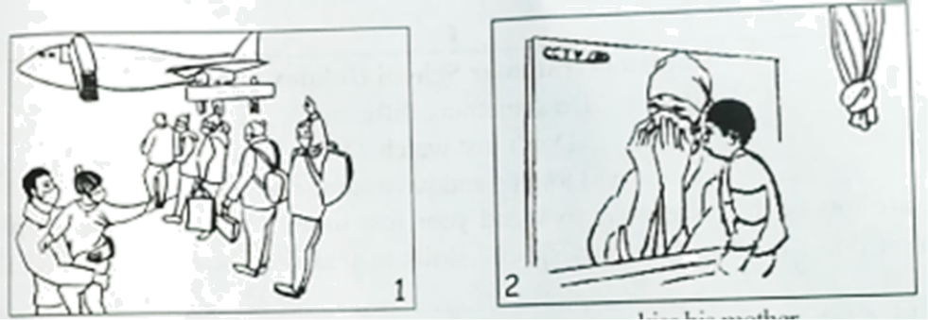

say goodbye kiss his mother

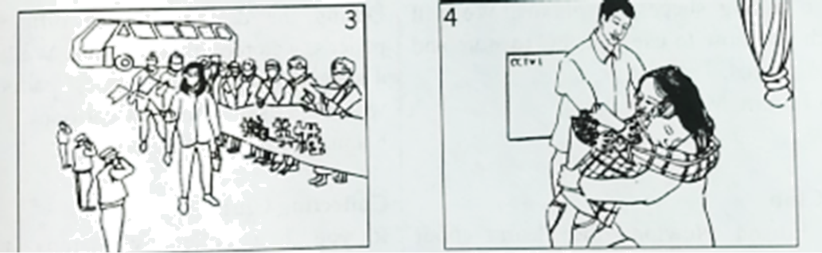

receive a warm welcome give her a big hug

注意：（1）短文须包括每幅图片的主要信息，可适当发挥，提示词语供参考；

（2）文中不得出现真实的地名、校名和人名；

（3）词数80左右。开头已给出，不计入总词数。

Li Shuo is a five-year-old boy. One Sunday afternoon, his mother was going Wuhan to help patients there.

________________________________________________________________________________________________________________________________________________________________________________________________________________________________________________________________________________________________________________________________________________________________________________________________________________________

## 参考答案

**笔试部分**

**Ⅵ.单项选择**

**选出可以填入空白处的最佳选项**

1-5 ABCAB 6-10 DCBDC

**Ⅶ.完形填空**

**阅读下面短文，从各小题所给的四个选项中选出最佳选项。**

【答案】11. A 12. A 13. B 14. D 15. C 16. C 17. D 18. B 19. A 20. B

**Ⅷ.阅读理解**

**阅读A、B、C、D四篇材料，然后从各小题所给的四个选项中选出最佳选项。**

【答案】21. D 22. D 23. B

【答案】24. A 25. B 26. C

【答案】27. A 28. D 29. A 30. C

【答案】31. C 32. D 33. A 34. B 35. B

**Ⅸ.任务型阅读**

**阅读下面短文，按要求完成下列各题。**

【答案】36. read books and newspapers

37. He can just remove or cut it. / By removing or cutting it.

38. Because it may stop working suddenly.

39. Technology helps us get important information in no time.

40. 当学生在写字的时候，他们能够与朋友们在另一个窗口讨论。

**X.词语运用**

**阅读下面短文，在空白处填入一个适当的单词或括号内单词的正确形式。**

【答案】41. felt

42. an 43. quickly

44. how 45. steps

46. from 47. us

48. cooked 49. more

50. first

**Ⅺ.基础写作**

**A）连词成句**

**将所给词语连成句子，要求符合语法，语句通顺，大小写正确，词语不得重复使用标点已给出.**

51.【答案】Would you like some tea?

52.【答案】What is your temperature

53.【答案】Pass me that yellow ruler.

54.【答案】There is a zoo near here.

55.【答案】Kate returned the bike on time

**B）书面表达**

56.【答案】例文：

Li Shuo is a five-year-old boy. One Sunday afternoon, his mother was going Wuhan to help patients there. His father took him to say goodbye to her. One day, he saw his mother on TV while she was away. He missed her so much that he kissed his mother across the TV screen. When the outbreak was under control, his mother came back with other medical workers. They received a warm welcome. As soon as his mother got home, Li Shuo gave her a big hug. How he misses his mother!